Đề 2:

Phần 1 :

Câu 1: import pytest

def checkbcd(inb):

    if inb >= 0 and inb < 1001:

        return True

    else:

        return False

try:

    num = int(input("Input binary value: "), 2)

    checkbcd(num)

except ValueError:

    print("Please input only binary value.")

#Test

a_equal = 100

a_ans = True

b_1bigger = 1100

b_ans = False

c_empty = 123

c_ans = False

@pytest.mark.parametrize("x,y",[(a_equal,a_ans),(b_1bigger,b_ans),(c_empty,c_ans)])

def test_combine(x,y):

    assert y==checkbcd(x)

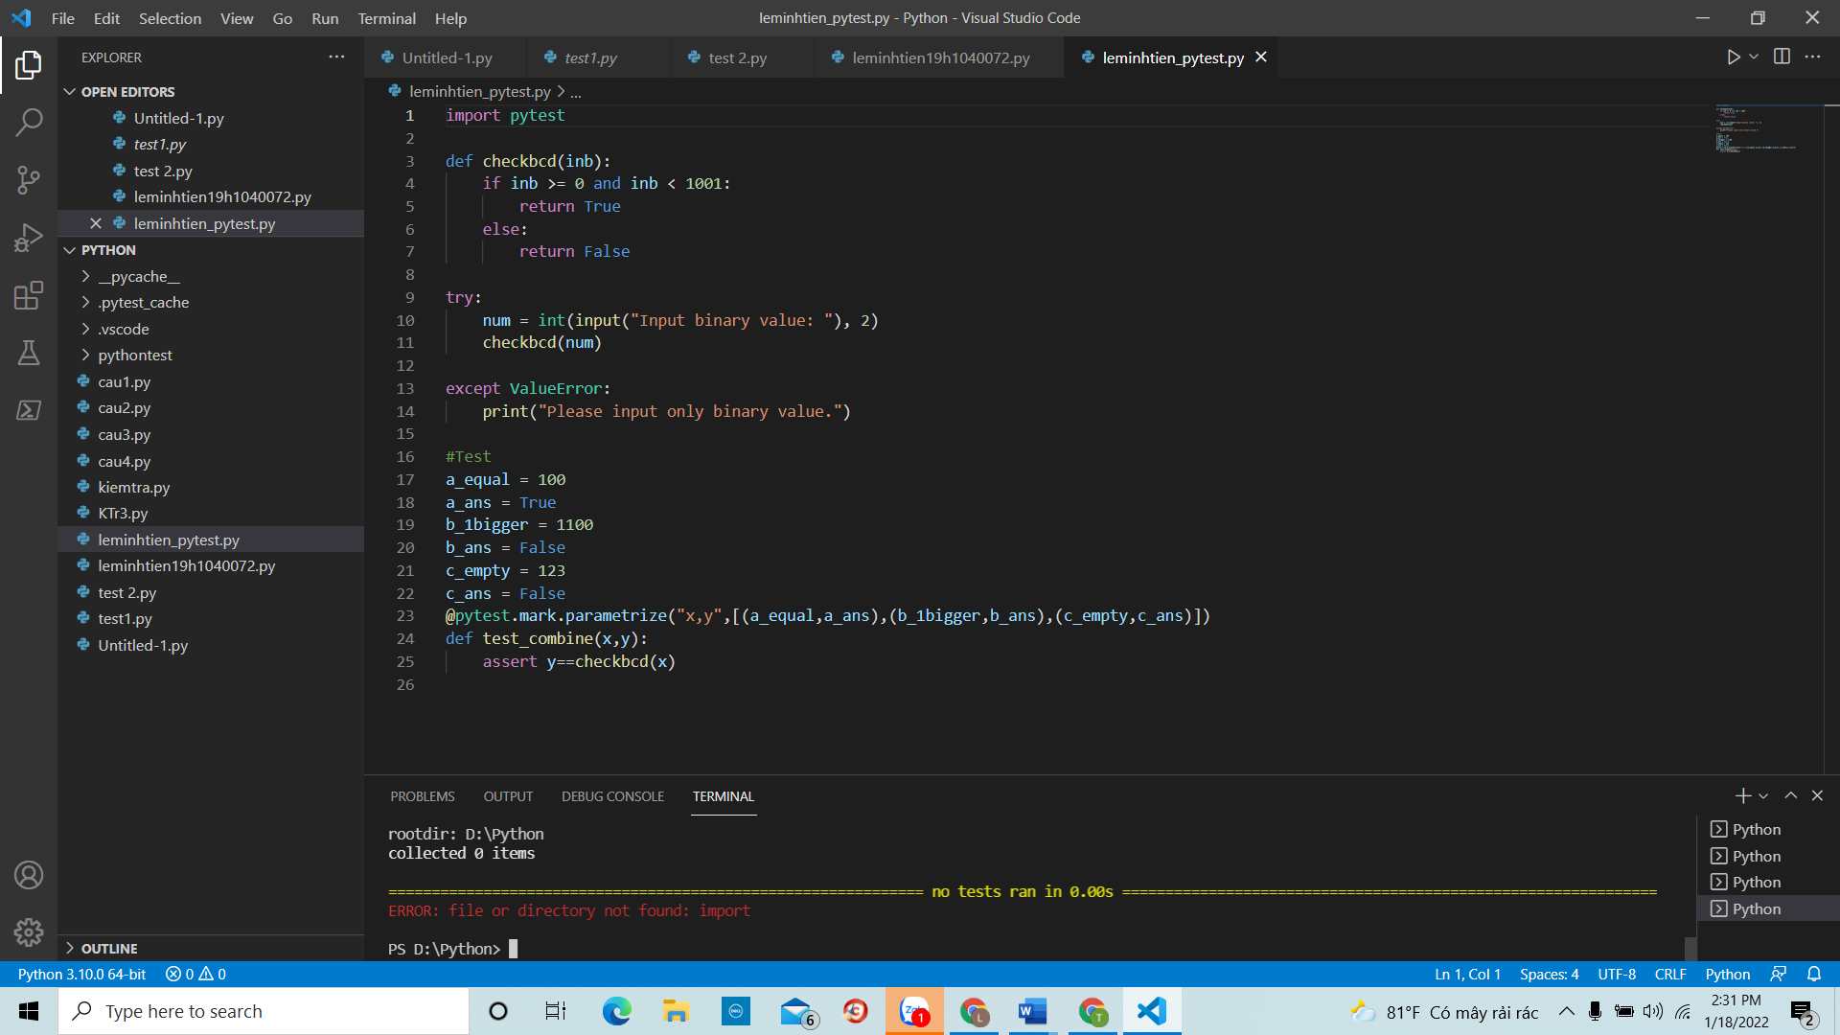

Phần 2 :

Câu 1:

n = float(input("Moi nhap real_number: "))

m = float(input("Moi nhap image_number: "))

class Sothuc :

    def __init__(self,real_number) :

        self.real_number = real_number

    def sothuc(self) :

        return (self.real_number **2) ** 0.5

class Sophuc(Sothuc) :

    def __init__(self,real_number, image_number) :

        super().__init__(real_number)

        self.image_number = image_number

    def module(self) :

        return (self.image_number**2 + self.real_number**2) ** 0.5

sothuc = Sothuc(n)

print("Module cua so thuc la: ",sothuc.sothuc())

sophuc = Sophuc(n,m)

print("module cua so phuc la: ",sophuc.module())

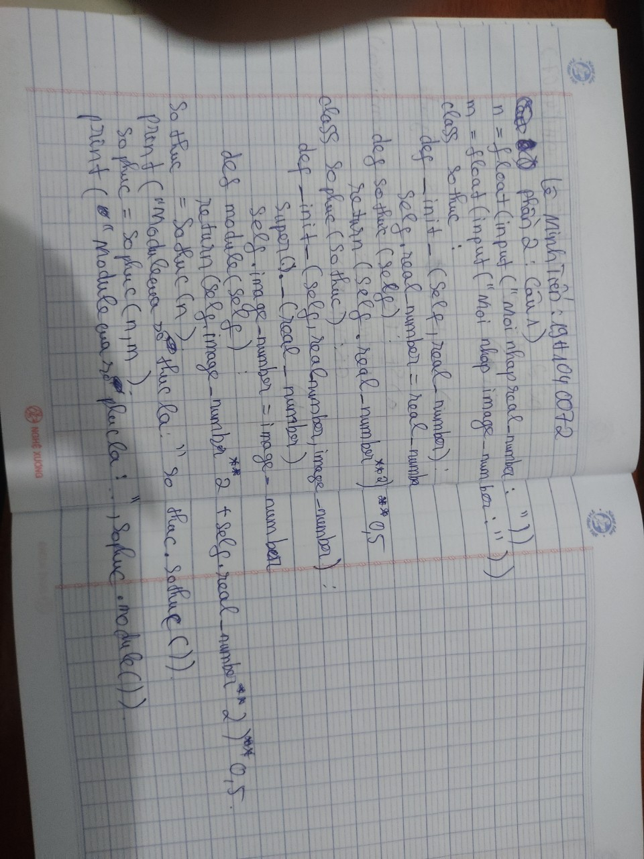

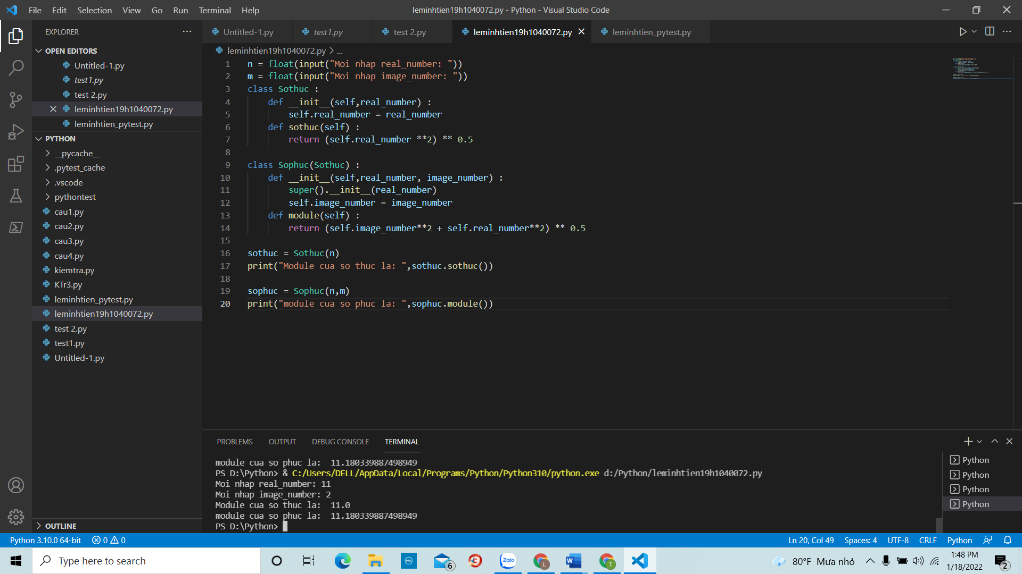

Câu 2:

SELECT city, sum(commission)

FROM salesman

Group BY city;

b)

SELECT a.cust_name AS "Customer Name",

a.city, b.name AS "Salesman", b.commission

FROM customer a

INNER JOIN salesman b

ON a.salesman_id=b.salesman_id

WHERE b.commission>0.12;

